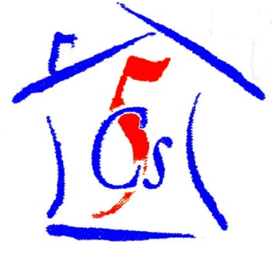

***C****hernobyl* ***C****hildren* ***C****ancer* ***C****are* ***C****ardiff*

53 Heol Llanishen Fach Rhiwbina Cardiff CF14 6LB

Tel: +44 (0)29 20624730

www.five-cs.org info@five-cs.org

Registered Charity Number: 1077451

**Having just returned from another successful summer at the Hospice summer camp in Zabrodie, we thought we would update you with all our antics! We sent 28 volunteers to the camp this summer, consisting of past volunteers and members as well as new faces from the Interact clubs of Howells School Llandaff and Whitchurch High School in Cardiff. Some of the volunteers were appointed for child care, helping the camp to run day to day. They worked hard as part of an international volunteer group to plan all the activities and keep the camp running smoothly. Another group of volunteers maintained all of the buildings to last the winter in preparation for next year.**

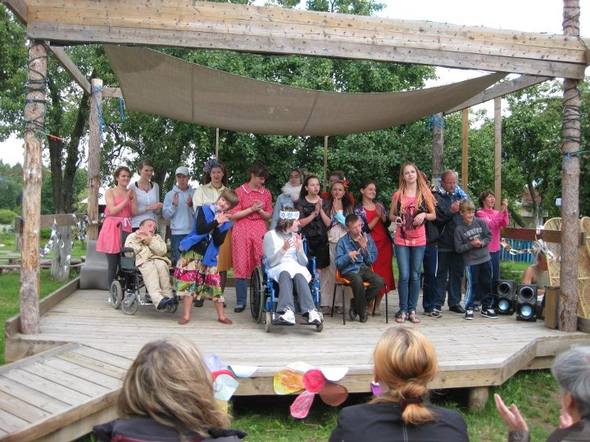

**We have had great feedback from the Hospice about all our volunteers. We hope they all valued the experience and take away some great memories from their summer with the children of the Belarusian Children’s Hospice**.

**We have recently purchased some land near the summer camp with the view of building our own volunteers house for the Hospice to use throughout the year and for us to be able to take more volunteers in the summer. We are really excited about this new venture and we will keep you all updated with its progress!**

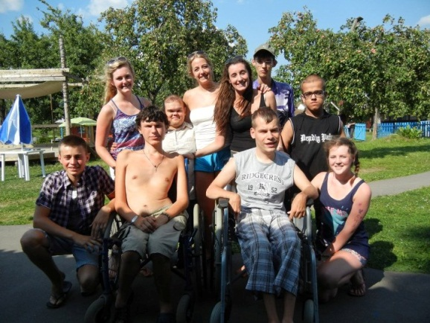

**We have just had our AGM and planned a re-structure of The 5Cs to enable us to grow and be the most successful we can be. We now have a panel consisting of seven trustees, with the newest addition being Thomas Pacey, welcome and congratulations! We then have five team leaders and twenty six members!**

**We are so grateful for the huge support we are shown by everyone and we hope we can have another successful year.**

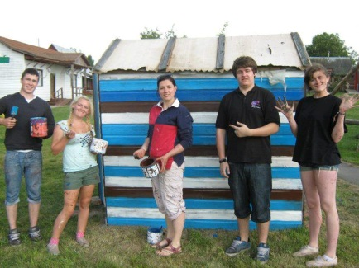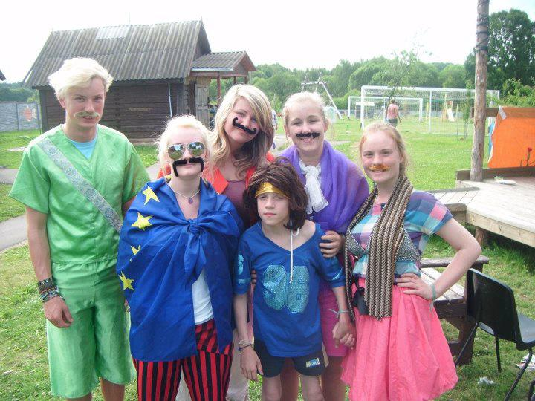

**Our next fundraiser will be a themed cocktail party- keep your eyes peeled for more information via email, the website and facebook!**

**As always please see our website at** [**www.five-cs.org**](http://www.five-cs.org) **or our Facebook page (search Chernobyl Children Cancer Care Cardiff) for more detailed and up to date information, photos and contact information.**

**We are so grateful for all the support everyone has shown so far and we look forward to a successful future!**

***Beth and all the 5Cs team!***